Eric Tuan
23 October 2006
AP Biology
Period 3
The Effect of Temperature on Cellular Respiration by Germinating Peas, Dried Peas, and Glass Beads

Introduction/Background:

Aerobic cellular respiration is the process by which energy is released from organic compounds by the catabolic pathway of chemical oxidation within cellular mitochondria. In cellular respiration, oxygen is used as the final step of an electron transport chain, in which electrons harvested from glucose (6-carbon sugar) molecules fall down an energy gradient, releasing energy to produce ATP. (Campbell et al., 2005) The oxidation of glucose into water or carbon dioxide depends on whether there is a sufficient supply of oxygen present. (Layher, 2005) Oxygen’s high electronegativity pulls electrons towards it down the electron transport chain, releasing the energy to create a proton-motive force across the membrane. The energy of the H+ gradient across the membrane is utilized to produce ATP through chemiosmosis. (Campbell et al., 2005) In the laboratory experiment, the rate of cellular respiration in germinating peas, glass beads, and a mixture of dried peas and glass beads was measured by examining the consumption of this limiting reactant, oxygen. Each group of peas, with volume equalized to the volume of the germinating peas by the use of glass beads, was placed in a water bath of a low (10-11 C) or high temperature. A respirometer was placed over the top of the test tube containing the peas or glass beads, to measure the oxygen consumption by the peas, a measure of cellular respiration. KOH was used to remove the CO2 from the reaction vessel to form a precipitate, leaving O2 the only remaining gas in the respirometer. The consumption of O2 was measured by the amount of water entering the respirometer as the gas inside the respirometer was utilized by the peas for cellular respiration. The experiment was designed to examine whether germinating peas performed cellular respiration and consumed oxygen at a higher rate than the mixture of dried peas and glass beads. The Q10 values for the temperature span of 10 degrees (created by the addition of ice to half of the sections) demonstrate that the germinating peas performed cellular respiration at a higher rate than the mixture of dried peas and glass beads. The Q10 value for the germinating peas (Period 4) was a relatively high 2.70 (Graph III), signifying that the consumption of oxygen by the germinating peas was a process that could be accounted for by biological means (i.e., cellular respiration). On the other hand, the Q10 value for the mixture of dried peas and glass beads (Period 4) was not calculable, because the rate of oxygen consumption at the low temperature (20.7 C) was a negative value (Graph IV). The low value for the Q10 of the dried peas/glass beads mixture implies that the reaction consuming oxygen was a purely physical one and could be accounted for by the gas laws, rather than being caused by a biological process such as cellular respiration. (Eskandari, 2006)

Results:

Table I
The Effect of Time on Oxygen Consumption by Germinating Peas and Dried Peas Mixed with Glass Beads (Low Temperature: 10.67 C)
Cold | Mean Temperature | 10.67 C |  | Period 3
Time (min) | Beads |  | Germinating Pea | Dried Peas and Glass Beads
5 | 0.117 | 0.233 |  | 0.087
10 | 0.117 | 0.283 |  | 0.107
15 | 0.107 |  | 0.287 | 0.117
20 | 0.090 | 0.405 |  | 0.166

Table II
The Effect of Time and Temperature on Oxygen Consumption by Germinating Peas and Dried Peas Mixed with Glass Beads (Room Temperature: 20.7 C)
Warm | Mean Temperature | 20.7 C | Period 3
Time (min) | Beads | Germinating Pea | Dried Peas and Glass Beads
5 | 0.073 | 0.2 | 0.093
10 | 0.07 | 0.277 | 0.1
15 | 0.08 | 0.4 | 0.103
20 | 0.087 | 0.46 | 0.107

Graph I
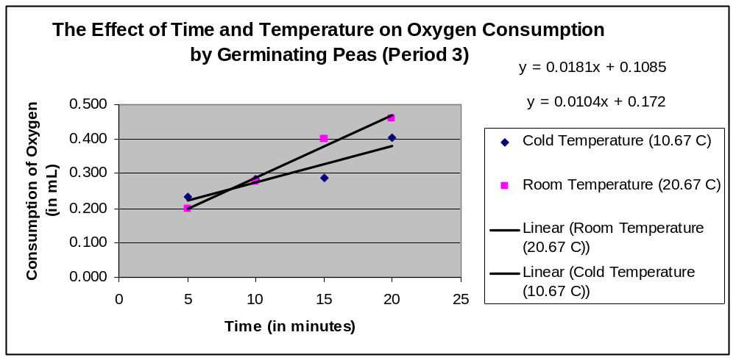

Q10 Calculation:

Unit | Value
T1 | 10.67 C
T2 | 20.67 C
R1 | 0.0104 mL/min
R2 | 0.0181 mL/min
Q10 | 1.7403846153846154

Significance: value close to 2 indicates a physical, not fully biological process

Graph II
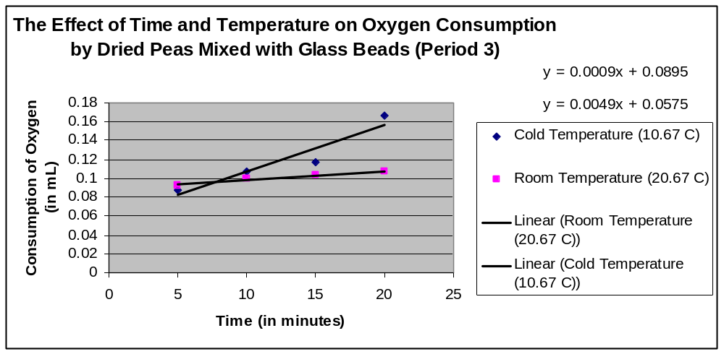

Q10 Calculation:

Unit | Value
T1 | 10.67 C
T2 | 20.67 C
R1 | 0.0049 mL/min
R2 | 0.0009 mL/min
Q10 | 0.18367346938775517

Significance: value less than 1 indicates a purely physical process, not a biological one

Table III
The Effect of Time and Temperature on Oxygen Consumption by Germinating Peas and Dried Peas Mixed with Glass Beads (Low Temperature: 10.17 C)
Cold | Mean Temp: 10.17 C |  | Period 4
Time (min) | Beads | Germ | Dried Peas and Glass Beads
5 | 0.141667 | 0.238333 | 0.2317
10 | 0.126667 | 0.31 | 0.25
15 | 0.101667 | 0.331667 | 0.24
20 | 0.078333 | 0.348333 | 0.225

Table IV
The Effect of Time and Temperature on Oxygen Consumption by Germinating Peas and Dried Peas Mixed with Glass Beads (Room Temperature: 20.7 C)
Warm | Mean Temp: 20.7 C |  | Period 4
Time (min) | Beads | Germ | Dried Peas and Glass Beads
5 | 0.037 | 0.107 | 0.04
10 | 0.037 | 0.183 | 0.043
15 | 0.0417 | 0.2417 | 0.0417
20 | 0.0417 | 0.295 | 0.045

Graph III
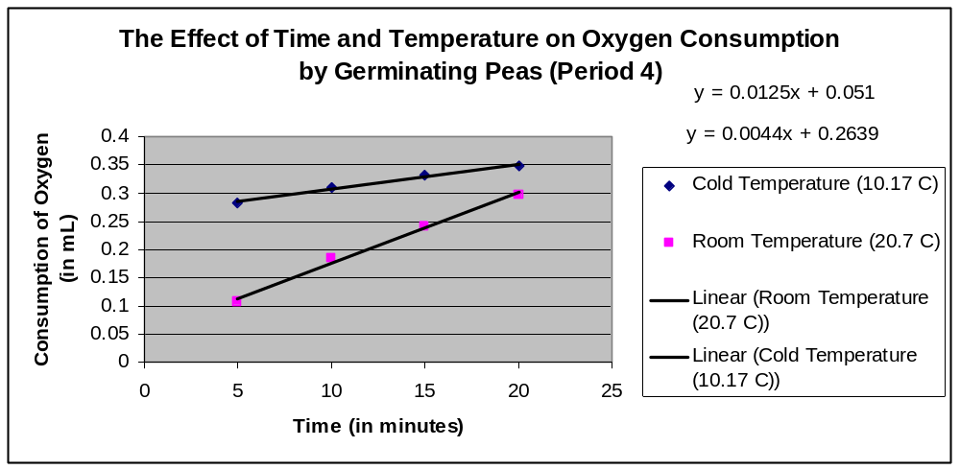
Q10 Calculation:

Unit | Value
T1 | 10.17 C
T2 | 20.7 C
R1 | 0.0044 mL/min
R2 | 0.0125 mL/min
Q10 | 2.6954653158992863

Significance: value greater than 2 indicates a biological process, not a purely physical one

(Turn the page for more results)

Graph IV
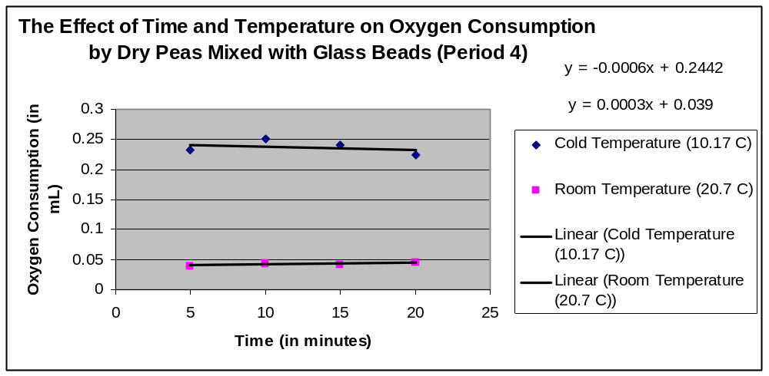

Q10 Calculation:

Unit | Value
T1 | 10.17 C
T2 | 20.7 C
R1 | -0.0006 ml/min
R2 | 0.0003 mL/min
Q10 | Not calculable

Significance: Q10 value is not calculable because the rate of oxygen consumption at the low temperature (10.17 C) is a negative value. The incalculability of the Q10 value implies that the process is purely physical, rather than biological.

Trend Paragraph:

The overall trend demonstrated in this laboratory experiment was that the germinating peas were consuming oxygen at a higher rate than the dried peas/glass beads mixture, implying that the germinating peas were performing the biological process of cellular respiration while the dried peas/glass beads mixture was not. In both class periods, under controlled conditions, the germinating peas consumed a larger amount of oxygen than the non-germinating peas. For example, after 15 minutes, (in Period 4), the germinating peas had consumed 0.332 mL of oxygen, while the mixture of dried peas and glass beads only consumed 0.240 mL of oxygen (Table III). The Q10 values for the temperature span of 10 degrees (created by the addition of ice to half of the sections) demonstrate a similar trend. The Q10 value for the germinating peas (Period 4) was a relatively high 2.70 (Graph III), signifying that the consumption of oxygen by the germinating peas was a process that could be accounted for by biological means (i.e., cellular respiration). On the other hand, the Q10 value for the mixture of dried peas and glass beads (Period 4) was not calculable, because the rate of oxygen consumption at the low temperature (20.7 C) was a negative value (Graph IV). The low value for the Q10 of the dried peas/glass beads mixture implies that the reaction consuming oxygen was a purely physical one and could be accounted for by the gas laws, rather than being caused by a biological process such as cellular respiration.
Two different data trends are demonstrated by examination of the relationship between temperature and oxygen consumption by germinating peas. For example, the trendline in Graph III, plotting length of time against amount of oxygen consumed for Period 4, is much higher for the series of data from the low-temperature reading (10.7 C). Although the trendline for the high-temperature data has a steeper slope, the trendline is still considerably lower than the trendline for the low-temperature data. At the 15-minute point, the amount of oxygen consumed by the germinating peas at high temperature was 0.242 mL – in contrast, the amount of oxygen consumed by the germinating peas at low temperature was a 27% higher 0.332 mL. However, the data for period 3 contradicts this trend because at several points, the amount of oxygen consumed by the germinating peas at the high temperature exceeds the amount of oxygen consumed at the low temperature. For example, at the 20-minute point, the germinating peas at high temperature (20.7 C) consumed 0.46 mL of oxygen, while the germinating peas at low temperature (10.67 C) consumed 0.405 mL of oxygen (Table I, Table II). These two apparently contradictory data trends demonstrate that the laboratory experiment was inconclusive on the relationship between temperature and cellular respiration.

Conclusion:

In the laboratory experiment, the rate of cellular respiration in germinating peas, glass beads, and a mixture of dried peas and glass beads was measured by examining the consumption of this limiting reactant, oxygen. Cellular respiration consumes oxygen, whose high electronegativity is used to pull electrons down the electron transport chain, releasing energy for the synthesis of ATP. (Campbell et al., 2005) KOH was used to remove any CO2 remaining in the respirometer, forming a precipitate so that the only measure of cellular respiration was oxygen consumption by the peas. The data demonstrate a clear trend – germinating peas consumed oxygen and performed cellular respiration at a higher rate than the mixture of dried peas and glass beads. For example, after 15 minutes, (in Period 4), the germinating peas had consumed 0.332 mL of oxygen, while the mixture of dried peas and glass beads only consumed 0.240 mL of oxygen (Table III) The Q10 value for the germinating peas (Period 4) was a relatively high 2.70 (Graph III), signifying that the consumption of oxygen by the germinating peas was a process that could be accounted for by biological means (i.e., cellular respiration). On the other hand, the Q10 value for the mixture of dried peas and glass beads (Period 4) was not calculable, because the rate of oxygen consumption at the low temperature (20.7 C) was a negative value (Graph IV). The low value for the Q10 of the dried peas/glass beads mixture implies that the reaction consuming oxygen was a purely physical one and could be accounted for by the gas laws, rather than being caused by a biological process such as cellular respiration. (Eskandari, 2006)
The data do not show a clear relationship between temperature and oxygen consumption by germinating peas. For example, Period 4 demonstrated a clear preference by the peas for a lower temperature - at the 15-minute point, the amount of oxygen consumed by the germinating peas at high temperature was 0.242 mL, while the amount of oxygen consumed by the germinating peas at low temperature was a 27% higher 0.332 mL. However, the data from Period 3 contradicts this trend, because at several points in time, the amount of oxygen consumed by the germinating peas at the high temperature exceeds the amount of oxygen consumed at the low temperature. As a result, the data from the experiment fails to show a clear relationship between temperature and oxygen consumption. However, the vast majority of experiments performed by scientists demonstrate that the germinating peas prefer warm temperatures. (Layher, 2005) The scientists’ erroneous results were probably caused by the difficulty in accurately measuring oxygen consumption in the respirometer. The scientists had a great deal of difficulty in accurately reading the level of water and oxygen in the respirometer, which affected our results dramatically. Also, immersing the dried peas in water may have caused them to begin cellular respiration as well – this error would have resulted in artificially high respiration rates by the dried peas/glass beads mixture. This laboratory experiment demonstrated that cellular respiration by germinating peas, as opposed to a mixture of dried peas and glass beads, is a significant biological process rather than a purely physical one.

References:

Campbell, N. and Reece, Jane B. (2005) Biology, 7th Edition. (168-174)

Eskandari, Sepher. Temperature Coefficient (Q10). Retrieved October 22, 2006 from CSU Pomona Physiological Calculators.
Website: http://www.csupomona.edu/~seskandari/physiology/physiological_calculators/Q10.html

Layher, Kris. Lab 5: Cellular Respiration. Retrieved October 23, 2006 from Suffolk Public Schools Biology.
Website: http://sps.k12.ar.us/massengale/lab_5_cellular_respiration_by_kr.htm

